**ISM 6208: Data Warehousing**

**Assignment 2: Analytic SQL**

Ankita Patidar

Pranali Kanade

Pranjal Shrivastava

### **Query 1: Aggregations with CUBE and ROLLUP**

This query utilizes the CUBE extension within the FIN S&P data.

Query:

SELECT

sps.COMPANY, sps.GICS_SECTOR, spesf.TRADE_DATE,

ROUND(AVG(spf.VOLUME),2) AS Avg_Vol

FROM

FIN.SP500_STOCKS sps

INNERJOIN FIN.SP500_EOD_STOCK_FACTS spesf

ON sps.TICKER_SYMBOL = spesf.TICKER_SYMBOL

WHERE

sps.GICS_SECTOR IS NOT NULL

GROUP BY

CUBE(sps.COMPANY, sps.GICS_SECTOR, sps.TRADE_DATE);

The CUBE extension calculates all possible combinations of the COMPANY, GICS_SECTOR, and TRADE_DATE dimensions with the AVG TRADING VOLUME. In this circumstance, we can determine which companies/sectors traded substantially above or below its historical average and investigate what events occurred around that time to warrant such increased trading activity.

Output:

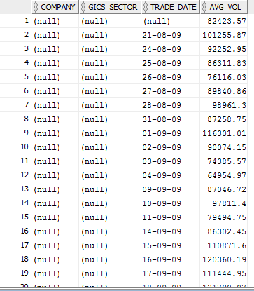

### **Query 2: Computing RANKs**

This query utilizes the RANK extension within the FRED_FEDFUNDS data.

Query:

SELECT

FF_DATE, FF_YEAR, FF_RATE,

RANK() OVER (PARTITION BY FF_YEAR ORDER BY FF_RATE desc) AS RANKING

FROM

FIN.FRED_FEDFUNDS;

When multiple rows have the same FF_RATE, they are assigned the same rank but the next rank is not in sequence (like Olympic medaling).

Output:

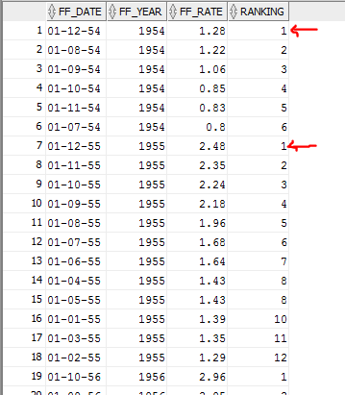

This query utilizes the DENSE_RANK extension with the FRED_FEDFUNDS data.

Query:

SELECT

FF_DATE, FF_YEAR, FF_RATE,

DENSE_RANK() OVER (PARTITION BY FF_YEAR ORDER BY FF_RATE) AS RANKING

FROM

FIN.FRED_FEDFUNDS;

Using DENSE_RANK assigns consecutive ranks (not like Olympic medaling).

Output:

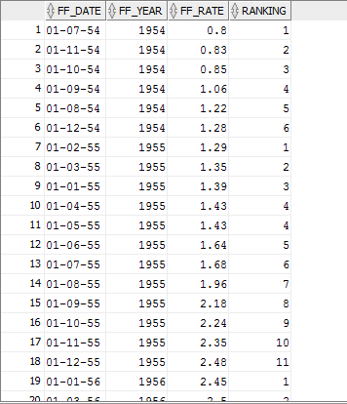

**Query 3: Creating Bins with NTILE**

This query utilizes the NTILE extension within the FIN S&P data.

SELECT FF_DATE, FF_YEAR, FF_RATE,

NTILE(5) OVER (PARTITION BY FF_YEAR ORDER BY FF_RATE) AS quintile

FROM

FIN.FRED_FEDFUNDS;

This query uses NTILE to create deciles that bin the different years. The following example divides the values in the year column of the fin.fred_fedfunds table into 10 buckets. The year column has total 693 values, so the three extra values (the remainder of 693 / 10) are allocated to buckets 1, 2 and 3, which therefore have one more value than buckets 4-10.

SELECT

ff_rate, ff_year,

NTILE(10) OVER ( ORDER BY ff_year DESC) AS bins

FROM

fin.fred_fedfunds;

Output:

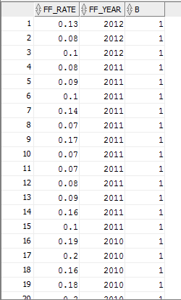

In this second query we grouped the data by year and used NTILE within the partitions to assign values.

SELECT

ff_rate, ff_year,

NTILE(10) OVER ( PARTITION BY ff_year ORDER BY ff_rate DESC ) AS b

FROM

fin.fred_fedfunds;

Output:

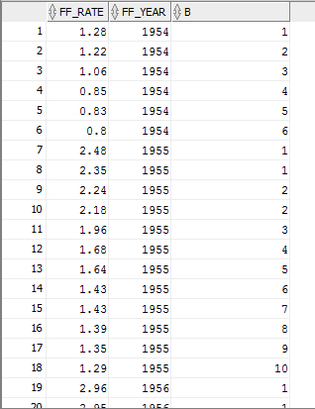

**Query 5: Leading and Lagging Indicators**

This Query to select stock open, stock close, previous close(lag), Nextopen(lead) from sp500 data along with its impact on gdp, with previous gdp into account.

Query:

SELECT

trade_date, close,

LAG(close, 1, 0) OVER (ORDER BY trade_date ASC) AS prv_cls, open AS wkly_opn,

close AS wkly_cls,

LEAD(open, 1, 0) OVER (ORDER BY trade_date ASC) AS nxt_opn, Gdp_value,

LAG(Gdp_value,1,0) OVER (ORDER BY trade_date ASC) AS Prv_gdp

from

dberndt.sp500_daily_facts

INNER JOIN dberndt.fred_gdp ON (dberndt.sp500_daily_facts.Trade_date = dberndt.fred_gdp.gdp_date)

ORDER BY

trade_date ASC;

Output:

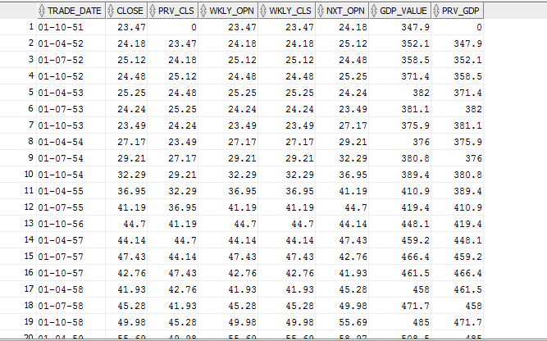

**PART II: Interesting Queries**

**Query 1:**

This query is giving us insight about the revenue generated from different type of product category and their sub categories.

Here the column "Sales Overview" tells us whether there has been a profit or loss in the store.

Query:

SELECT

pdim.product_subcategory, pdim.product_category, COUNT(slsfct.order_id) AS "Order Total", SUM (slsfct.Sales) AS "Sales Total", SUM(slsfct.profit) AS "Total profit or loss",

(CASE

WHEN SUM(slsfct.profit) > 0

THEN 'profit'

ELSE 'loss'

END) "Sales Overview"

from

SuperStore.Product_Dim pdim INNER JOIN SuperStore.Sales_Fact slsfct ON pd.product_key = slsfct.product_key

GROUP BY ROLLUP ((pdim.product_subcategory, pdim.product_category));

Output:

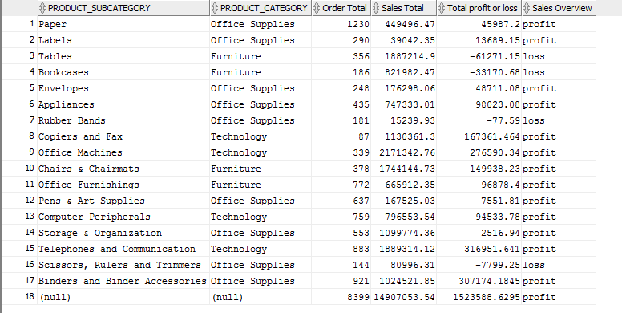

**Query 2:**

This query further expands upon the query created demonstrating RANK. It joins the fed funds rate table with the GDP table.

We then partition the RANK by year and order by GDP value. This can allow us to see if changes in the fed funds rate is a leading indicator to changes in GDP value.

Query:

SELECT

fd.FF_DATE, fd.FF_YEAR, fd.FF_RATE, fg.GDP_VALUE,

RANK() OVER (PARTITION BY fd.FF_YEAR ORDER BY fg.GDP_VALUE) AS GDP_RANK

FROM

FIN.FRED_FEDFUNDS fd

LEFT OUTER JOIN FIN.JULIAN_DAYS jul_dys ON fd.FF_DATE = jul_dys.ACTUAL_DATE LEFT OUTER JOIN FIN.FRED_GDP fg ON jul_dys.JULIAN_DAY = fg.JULIAN_DAY;

Output:

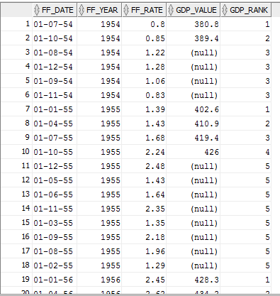

**Query 3:**

This query will find the correlations between products and categories within sales.

Query:

SELECT

pdim.product_key, pdim.product_name,

EXTRACT(YEAR FROM sf.order_date), RATIO_TO_REPORT(sf.order_quantity*sf.unit_price) OVER(PARTITION BY pdim.product_name) SALES_RATIO

from

superstore.product_dim pdim JOIN superstore.sales_fact sf

ON pdim.product_key = sf.product_key;

Output:

